VK4YE Compact End-Fed 5 Band HF Antenna
INTRODUCTION
End-fed antennas are increasingly popular again, at least partly because of compact ferrite toroid cores. Small cores facilitate easy-to-build low-power RF transformers and networks. The combination of lightweight matching systems, combined with the installation simplicity of NOT hanging a heavy coaxial feeder from a long span of thin antenna wire, has rekindled interest in end-fed half-wave antennas.
The 25m long antenna described here will get you on air without an ATU on 80m, 40m, 20m, 15m & 10m. It has been purposely reduced in length compared to a full sized 80m dipole by the insertion of a 70uH loading coil. At 7MHz, the impedance of the loading coil is about 3kΩ, and this effectively disconnects the tail of the antenna at 40m and above. The reason for reducing the size of the antenna is to enable operation on smaller house allotments as well as being compact enough for portable work. The length of the antenna from the feed point to the loading coil is 20.2m and this sets the 40m resonance at 7.1MHz, which in turn dictates the responses of the harmonically related bands 14MHz, 21MHz and 28MHz.
As the length of the antenna is around 2/3 of the span of a half-wave dipole on 80m, there are two compromises. Firstly, bandwidth on 80m is restricted to about 80 kHz at the 2:1 SWR points, and secondly, there will be a reduction of around 1.5 S points in both transmitted and received signals. This really is a good outcome where operation on 80m would otherwise be severely curtailed. Even better news is that the bands from 40m to 10m have no such limitations. Furthermore, the 17m band can be used with a radio’s internal ATU as the SWR is less than 3:1 at 18.1MHz. The length of the tail following the loading coil is used to set the 80m resonance. With a 4.2m tail, resonance is at 3.6MHz, which is the Dawn Patrol net frequency of the Summerland Amateur Radio Club (SARC).
The RF transformer uses an FT240-43 ferrite core and has a turns ratio of 2:13 (1:6.5). It transforms the 50Ω impedance of the coaxial feedline to around 2.1kΩ. At the 100 W level, expect in excess of 600V peak RF voltage at the antenna feed point. If the system is not perfectly matched, then this voltage will increase proportionally with the SWR.
FEEDING AN ANTENNA AT ONE END
The theoretical impedance of a center fed dipole antenna far removed from ground effects is around 73Ω. As the feed point moves towards one end, the impedance gradually increases to 2kΩ or more. An off center fed dipole when fed at 1/3 of its length from one end shows an impedance of around 200Ω +/- 100Ω. Some commercially available antennas are marketed as being end fed and employ a 1:9 unun to feed at a supposed 450Ω impedance point. Such antennas require what is erroneously called a counterpoise attached to the matching unit to reduce the SWR. These antennas are really just “extremely off center fed dipoles” where the counterpoise is nothing more than the missing part of the antenna. From experience, it is very difficult to achieve an acceptable SWR except on the band for which it can be made resonant. Commercial versions openly state that no counterpoise is necessary so long as there is at least 10m of coaxial cable from antenna to radio. Sounds too good to be true, however the outer surface of the coax’s braid behaves like the missing section of the antenna and thus radiates. Without the use of a common mode choke (CMC) at the entry to the shack, there is a high risk of the radio and associated gear being hot with RF. This risk increases dramatically when running high power.
The VK4YE end fed antenna does need a small ‘counterpoise’ of 0.05 wavelengths at the lowest operating frequency. The reason is not complicated. You cannot simply connect a generator of RF energy to the end of a wire and expect to have an optimal radiating system. Whatever current flows from the generator into the antenna must be accompanied by precisely the same current flowing into the other terminal of the generator. Put another way, the generator needs something to facilitate the flow of that current. In practice, the braid of the coax cable is an effective substitute for a ‘mini counterpoise’. Stray RF in the shack is not nearly so serious as for the 1:9 unun approach because a lower current is flowing into a much higher impedance load, nonetheless a CMC should be connected to the coax feedline in the shack prior to the radio. I have never experienced RF feedback issues with the antenna set up this way.

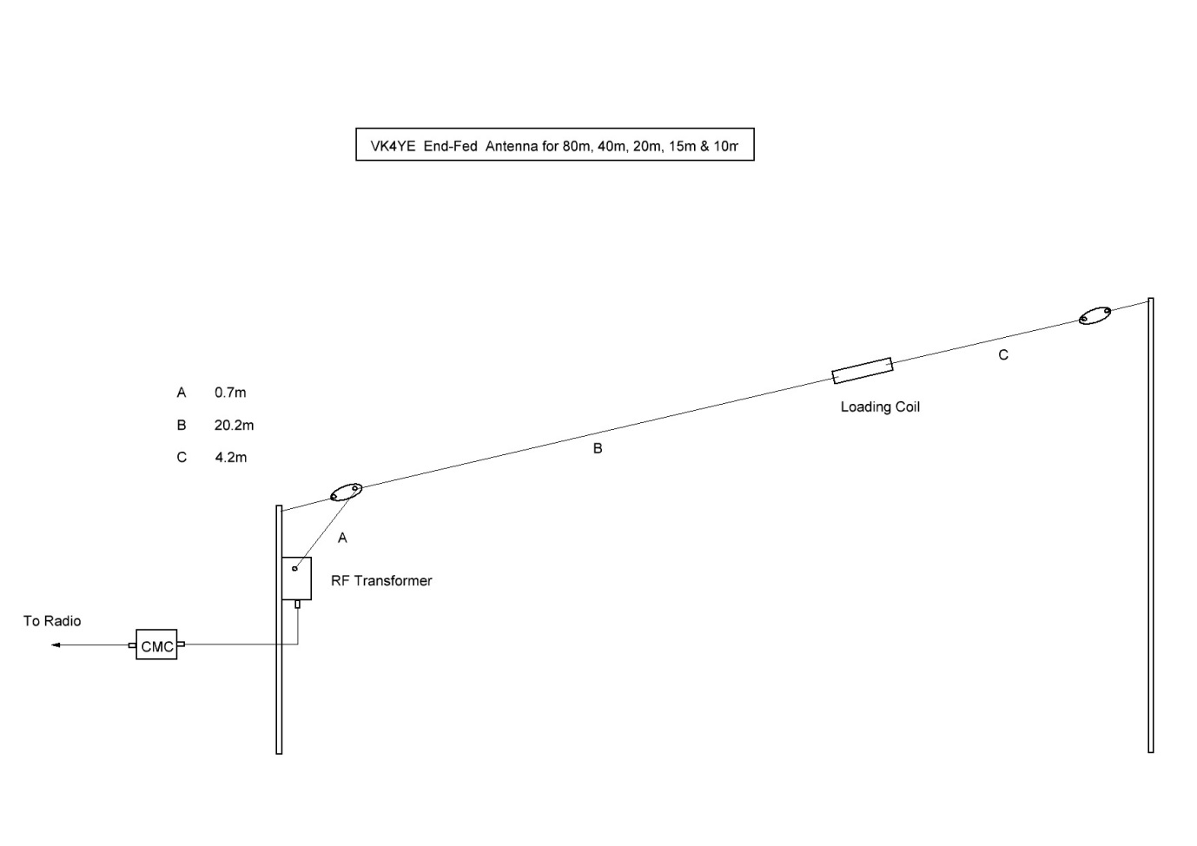

END FED LAYOUT
The simplest approach to erecting the antenna is to set it up as a sloper ….. one high support only is required. The feed point can be a couple of metres above ground, but certainly must be high enough to be out of arm’s reach. RF burns can be painful! A 4m run of coax from the matching unit to the CMC and radio will suffice as the ‘counterpoise.’ A longer run should have no effect on the operation of the antenna. In portable operation, one well selected tree ought to be quite adequate to terminate the antenna (via an insulator of course).
SWR RESPONSES FOR THE VK4YE END FED ANTENNA
Here are the responses for the antenna ………

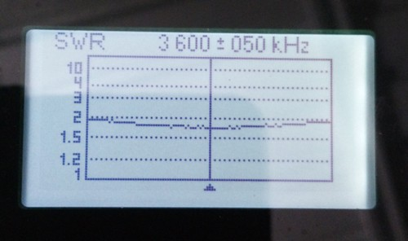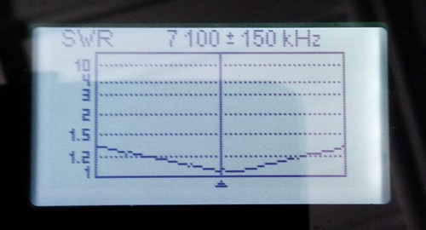

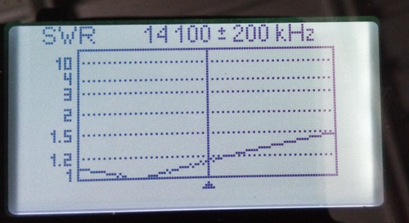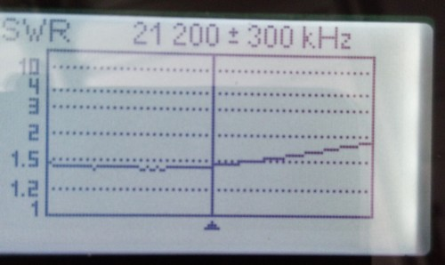

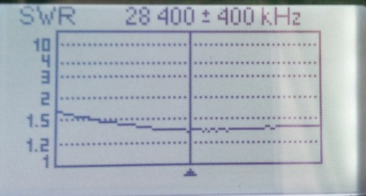

CONSTRUCTION DETAILS
If the proposed maximum power input to the matching unit is 100W PEP, then a Jaycar core type L01238 will suffice. Cores are sold by the pair for $6.95. This ferrite material has been assessed by Owen Duffy (ex VK1OD) to be broadly comparable to Amidon/Fair Rite type 43 mix and that gives a good response from 80m to 10m. It would be safe to assume that the L01238 core to be very similar in characteristics, including power handling capacity, to an FT140-43 toroid. Should you plan on high power operation, say 400W PEP unprocessed SSB, an FT240-43 core will be required. These are sold for around $9.90 each (plus shipping) by Mini Kits in Adelaide.
Many experimenters and commercial sellers of the RF matching transformer generally use a turns ratio of 1:7 or 1:8, giving an impedance transformation of 50Ω to 2.49kΩ and 50Ω to 3.2kΩ respectively. The transformer construction described here uses a ratio of 2:13 which gives a 50Ω to 2.1kΩ impedance step up.
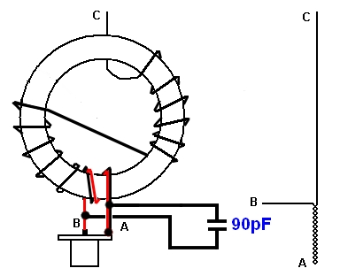
Whichever core is selected, wrap with two layers of plumber’s blue or pink Teflon thread tape. Don’t use the lighter grade white tape as it is too prone to electrostatic attraction and becomes very fiddly to wind.
To construct the RF transformer, cut off a 1m length of 1mm enamelled wire. Fold the wire back on itself 175mm from one end. This will be the start of creating the bifilar primary turns. Around 150mm of the folded wire needs to be twisted to form a 50Ω impedance winding. A variable speed hand drill is ideal for the purpose. Clamp the two wires in a vise, leaving around 30mm free to serve as the input marked B. The end marked A is inserted into the drill chuck and tightened. A twist of 2.5 to 3 turns per centimetre is required.
C is the high impedance output which connects to the antenna. Each time a wire is passed through the window of the toroid, one turn is created. The twisted bifilar section passes through the window twice, then 4 more turns are added to give an initial total of 6 turns. The next part requires the wire to go through the window again to the opposite side in what is known as the Reisert crossover winding method. 6 turns are then added. Refer to the diagram to see that this technique results in 13 turns in total, and the output C is located well away from the input side. The crossover creates one turn.
A capacitor across the input of the primary winding is necessary to offset the effect of the winding’s inductive reactance and improve the SWR above 15m. Experimentally, the value was determined to be larger than 75pF but smaller than 100pF for optimum results, 90pF is pretty much ‘on the money’ for this particular RF transformer. Two 180pF silver mica capacitors (standard 500V rating) are connected in series and wired across the 50 ohm input. If these capacitors are not readily available, a neat way of achieving an equivalent capacitor is to employ a 90cm length of RG58 coax. This cable shows around 30pF capacitance per 30cm. Trim back the braid for 1cm at the far end to lessen the chance of leakage currents flowing. Cover the end with heat shrink tubing. This cable can be wound up into a spool, kept together with cable ties and placed in the box containing the RF transformer. For those who are inclined to experiment and have access to an antenna analyser, connect a 2.2kΩ resistor from the unit’s antenna terminal to the coax ‘earth’ on the SO239 input socket. Start with 1m of coax cable connected across the primary input and gradually trim the coax while observing the graphed SWR response for the whole range from 80m to 10m. A point will be reached where the SWR looks similar to this display. The second picture shows the prototype RF transformer with a trimmer capacitor being used to optimise the SWR response.
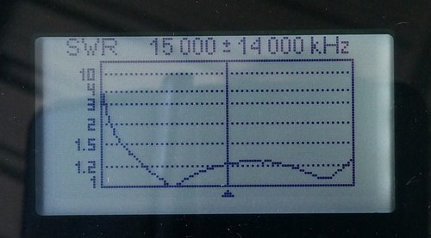
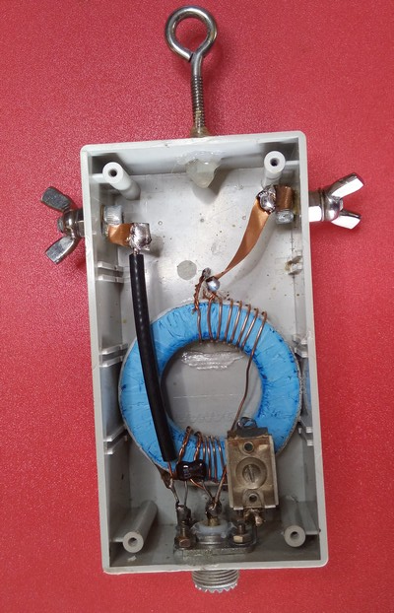
An earth connection was provided on the prototype, but was found to be unnecessary.
The next item to fabricate is the 70 uH loading coil. 25mm OD PVC conduit was used as this allows heatshrink tubing to be fitted over the winding for weather protection. 120 turns of 1mm enamelled wire was used – the pigtails being terminated on solder lugs. Separate solder lugs (not shown in the picture of the loading coil) were held in place by the same screw used hold the lug for the coil pigtails, and provided a termination point for the antenna wire. The whole lot was covered with 30mm diameter heatshrink tubing. Here are two pictures, firstly of the loading coil and strain relief insulators, then fully assembled. I recommend this approach be adopted as strain relief has to be provided to ensure long term survival in windy conditions.
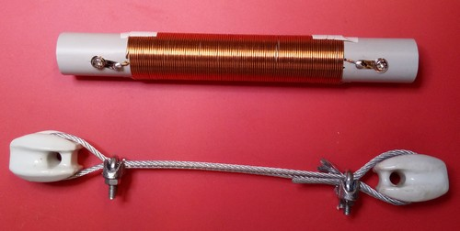

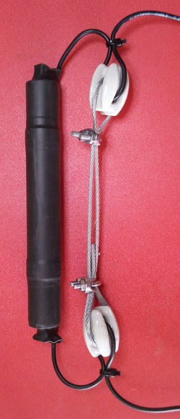

The antenna wire utilised was the ubiquitious 2.5mm² building wire. Multi-strand 1.5mm² building wire would be an even better choice. A run of 20.9m was used from the matching unit to the loading coil and 4.2m used after the loading coil. A little extra wire is necessary for terminating the 80m tail on an insulator and also to allow some adjustment for resonance in your favourite part of the band.
Strain relief must be provided at the matching unit. A black UV stabilised polyethylene egg insulator is ideal and the antenna wire can be passed through the insulator and secured with a cable zip tie or perhaps a wire grip. Allow a little extra wire for this section to experimentally determine the 40m resonance. When the lowest SWR occurs at 7.1 MHz fit a connector to the wire and attach it to the RF matching unit antenna terminal. The resonant point in the higher bands is set by the 40m resonance and will not be an exact multiple of it. I found that if you make the antenna resonant near 7.1 MHz, the higher bands have a satisfactorily low SWR in the more popular band segments.
An antenna analyser is a very handy tool for setting up this antenna. I used a Rig Expert AA54 where its ability to graph the SWR response was invaluable in quickly giving a snap shot of every band’s resonant point and bandwidth. For those whose tools are more basic, a radio putting out a signal of a few watts and a sensitive SWR meter will also give a reasonably clear assessment of the antenna.
THE COMMON MODE CHOKE
This is the last component in the system. A very effective choke can be constructed using the Jaycar ferrite core LO1234. These are sold in a pack of four at $6.95 (January 2021 price). RG58 coaxial cable passed through 8 cores 5 times is probably overkill, but does a top job in eliminating RF from being fed back to the radio. In fact this unit would be quite happy at the 1kW power level. A CMC more appropriate to a 100W pep station would use four of the toroids – 2 cores per side.
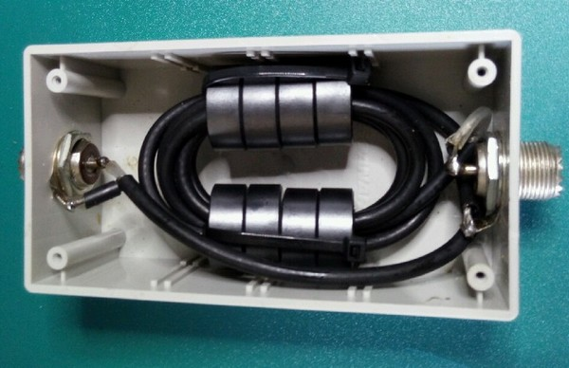
A jiffy box with SO239 connectors completes the unit. If one were to contemplate mounting the CMC outside the radio room, ensure there is at least a 4m run of coaxial cable to the RF transformer to serve as the ‘mini counterpoise’.

Enjoy
de Chris VK4YE 3 September 2018.

SUMMARY
Antenna Type End Fed 25.1m long with 70uH loading coil.
Bands 80m 40m 20m 15m 10m. 17m useable with radio’s internal ATU.
Power Rating 400W PEP unprocessed SSB with FT240-43 ferrite core.
100W PEP with Jaycar LO1234 or FT140-43 ferrite core.
Loading Coil 120 turns of 1mm enamelled wire on 25mm OD PVC former.
RF Transformer FT240-43 core, turns ratio 2:13 90pF compensation capacitor across the primary winding.
CM Choke 5 turns of RG58 coax cable through 4 x LO1234 ferrite cores.

